9.34: The distances of the masses from the axis are 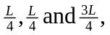 and so from Eq. 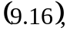 the moment of inertia is
